March 2008
COLUMBIA UNDERGROUND
PRESIDENT Linda Lowenberg 234-1650 NEWS OF THE COLUMBIA GARDEN CLUB 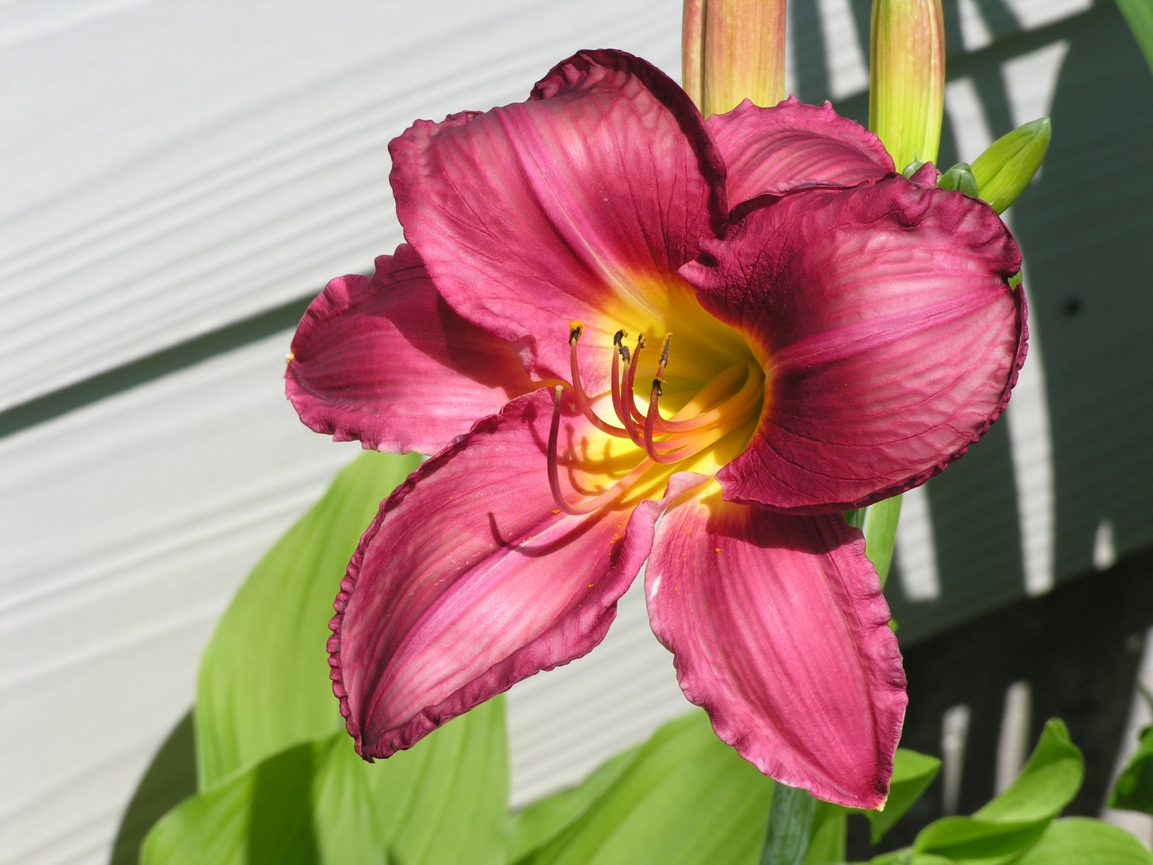 WELCOME BEAUTIFUL SPRING!
…………MAY BASKETS……………..
Mary Jane and Marie are planning a project to make and sell Mothers Day May Baskets at the Farmers Market. They appreciate any baskets you can spare that will make some mother happy! You may bring them to the next 2 meetings.

Calendar of Events:
March 10, 1 pm: “Beyond the Ordinary Plant”
March 7-9: Art in Bloom
April 14, 1 pm: “Mini Gardens Near and Beyond”
April 11-13: Flower Show School I-Kirkwood, Mo
April 12: Clean Up Columbia Day
April 16: Central District Spring Mtg.-Laurie, Mo
April 26: CGC Plant and Bake Sale and Garden Bazaar
April 24-28: NGC Convention-Memphis Tenn.
May 6-8: FGCM 75th Anniversary Convention, JC, Mo
May 10: Mother’s day Blooming Basket Sale farmer’s market
May 12, 1 pm: “A Touch of the Earth’s Beauty”
June 1-7: National Garden Week
June 7: CGC Flower Show-Columbia Public Library
June 9, 8:30 a.m.: Garden Tour: “Beyond Our Garden Gates”
August 7-17: Missouri State Fair (August 13th –Federation Day)
August 22=24: Flower Show School II
Sept. 15, noon: Annual Covered Dish Luncheon
“Natural Wonder beyond the Gate”
Oct. 9: Central District Fall Meeting, Booneville
TBA: Central District Bus Tour
Oct.13, 1 pm: “Tread Lightly on the Earth”
Oct. 14-16: Landscape Design School IV, St Louis
Nov. 10, 1 pm: “Beyond the Bird Feeder”
Nov. 13, 14: FGCM Fall Board Meeting-TBA
Dec. 8, noon: Holiday Tea

It was a cold and nasty day but the February meeting took place with 11 members and two new members actually attended and signed up! I am sure they were impressed by the good program by guest Kyle Gibson, Dir. Curriculum & Instruction for Dept. of Physical Therapy, University of Missouri. He specializes in knees and gave us many hints on how to garden and still take precautions against damaging our knees and other body parts as we kneel, sit and squat while gardening. His main hint: do everything in moderation. If we are experiencing pain, we should work in shorter segments, 10 minutes at a time instead of 30, for example.
………………………MARCH GUEST………………………………….
Join us for a power point presentation by Chris Starbuck, PhD.MU Associate Professor & State Extension Specialist of Woody Ornamentals, discussing the Plants of Merit program.

Please welcome our two new members and add them to your handbook:
Tanja Patton, 30 E Broadway, Columbia, Mo. 65203 tpatton2000@yahoo.com phone: 449-6320
Rose Mayfield, 4275 Lang Drive, Columbia, Mo. 65202
Mayflower812003@yahoo.com phone:808-6737
Editor: Karen Blackmore 442-1873 karen@kewpie.net

..ATTENTION……….ATTENTION…..…….ATTENTION………April 26 is just around the corner. This is our best chance to make money for our club! Now is the time to be planning what you can contribute as well as how you can help. We’ll talk more at the March meeting.
At March meeting each club needs to elect delegates to the convention. This will be most important this year because we will be electing the next Central Region Director. There are three qualified candidates - Betty Alloway, Joan Hood and Mary Ann Meador. By the way, have you registered? We still need hostesses as well. Deadline to register is April 15th! That date should be easy to remember!

TO DO’S: Clean out garage, prune a little, rake leaves and winter crap, get early fertilizer bought and put down, plant for the CGC April sale. Spring is almost here, time to get moving! Whew…clean out bird houses, put out bird food, and check my committee schedules!
Life is just full of fun things! Bring a friend to join us! We need all the help we can get!

Well, here it is time for another newsletter and not a lot of news! I look up articles and just have no luck finding anything you don’t already know. I guess I can adlib since I am in complete control so here goes. I have been in this house for eleven summers but have worked until the last four. I had a pretty good yard but have added many flowers since retiring. I have planted a lot of bulbs and have found that the deer eat all the tulips that I don’t spray very early and often. If the tulips are not eaten, the bulbs get smaller and the flowers smaller in a hurry. I have better luck with iris as I have a lot of sun and the deer don’t usually eat them. This winter they must be really hungry as they have eaten on them and have even pulled some out of the ground; eaten the rhizome and left the tough tops. You know us gardeners; I will keep trying as I know I can win! Mother used to say when I complained, “I’d rather have the deer.” I have found joy in the chomped off plant, I think of Mother. – Karen*
We collected 60 pounds of food for the food pantry! Thank you to those who contributed.


Tetanus Vaccination
In case you do not know, you should have a tetanus vaccination if you are working in the dirt as that is a place where tetanus lives! I got mine at the Boone County Health Dept and they are cheap, I think $10.00. You can just walk in and get one. A booster is in order if you have not had one in 10 years.

I need news! E-mail me at karen@kewpie.net or call me at 442-1873!

COLUMBIA GARDEN CLUB
MINUTES
February 11, 2008
The meeting was called to order at 2:20 p.m. following a program on “Arthritis, Gardening and other Exercise”. Kyle Gibson from the University of Missouri - Department of Physical Therapy, presented the program.
For roll call, members shared what physical activities they would do to strengthen their bodies for the gardening season. Thirteen members attended the meeting. We welcome new members, Rose Mayfield and Tanja Patton, who braved the icy conditions to be with us. Art Schneider made a motion to approve the January minutes as printed in the newsletter and Emily Bonwich seconded it. The motion passed. Treasurer Karen Blackmore reported a balance of $1,492.87 in the treasury and a C.D. balance of $2,855.05 for total assets of $4,347.92. The report was filed for audit. Kathy Shreve has audited the books for 2007.
A note was read from Marie Pasley thanking members for the gifts she received from the club honoring her as the new Central District Director.
Committee Reports were as follows:
Wyatt House & Columbia Public Library Arrangements- Chair Lynn Birkby said Mary Jane Wheeling will take a valentine arrangement to the Library and Alice Havard will take an arrangement to Wyatt House in February.
Ways and Means – Mary Jane Wheeling reported on plans for the CGC plant and Bake Sale, April 26. She said the Sadler’s will grow tomatoes and plants as they have done in the past. This year, flats will be purchased at a minimal cost from the Amish community at Clark. We discussed purchasing red shirts to wear at the sale. Mary Jane also mentioned a new project, Mothers Day Blooming Basket Sale, scheduled for May 10 at Columbia Farmers Market. This is the Saturday before Mothers Day. We may have a work day to make some of the baskets for children to buy for their mothers.
Linda Lowenberg collected the food items that were brought to the meeting for the food bank.
Our club has five members who will be attending the Flower Show School in Kirkwood in April. Those who helped at the spring symposium can receive $90 toward the costs of attending the school.
The Federal Garden Clubs of Missouri State Convention will be held in Jefferson City, May 6 – 8. Mary Jane said they will need hostesses to help throughout the convention. A sheet was passed for volunteers to sign their names to help. President Linda was agreed to serve as one of our delegates to the convention.
Announcements: The Central District Meeting will be held April 17 at Laurie, Mo. Steve Scotsdale, owner of a landscaping business, will speak. Subject –“So you’re Thinking about a Pond”.
See Linda if you need tabs for the Garden Club Manuel.
Karen Blackmore will chair the Pots to Planks recycling program at Superior Gardens this year. Pleases save any plastic pots you will not be using as they will be recycled in the useful program. More information to follow.
The meeting was adjourned at 2:50 p.m.
Virginia Itschner, Secretary


