COLUMBIA UNDERGROUND
News of the Columbia Garden club June, 2008

First Vice-President- Emily Bonwich 449-0444
Second Vice President-Arthur Schneider 445-5478
Secretary- Virginia Itschner 514-0032
Treasurer- Karen Blackmore 442-1873
President: Linda Lowenberg 573 234 1650 lindayjones@hotmail.com Editor: Karen Blackmore 573 442 1873 karen@kewpie.net

FLOWER SHOW June 7, 2008
The flower show is fast approaching and its success depends on our participation! Carolyn Doyle passed out the show schedule. Since the schedule was written up, there have been a few changes. Please make the following changes to your copy of the schedule:
Under 'Awards', (Top Hort. Awards), after 'Exhibit must be properly named. Delete the next sentence and add "A plant must be identified by its binomial name or its currently accepted scientific identification to be eligible for a Top Exhibitor Award."
Under Division II, Horticulture Rules, 2nd paragraph, add 'The correct scientific name is required for an exhibit to be eligible to win a Top Exhibitor Award. For some hybrid plants of undetermined species, the genus and cultivar or series is sufficient naming, e.g. Rosa 'English Garden' (cultivar), Saintpaulia 'Optimara Haiti' (series).
Hort. Section A, omit 'and Biennials'--we can no longer combine the two in one class.
And under Section 8, Collection, Barb reminded me that the Collector's Choice Award is a section award, and needs three classes, so;
Class 29 Annuals
Class 30 Perennials
Class 31 Ferns
We will set-up for the flower show the day before, on the 6th. We are asking all members who are able to meet in the Friends' Room at the Library on Friday the 6th, from 3 to 5 PM, to help set everything up. The tables will be there, but will probably need re-arranging. If you have the club tablecloths, please bring them, or contact Carolyn Doyle if you can't be there. We'll need them for the tables.
There will be a room set up near the show for final grooming and completing the identification cards prior to making your entries. In order to comply with the schedule and conserve time, please bring the scientific names of your entries written out so that we do not have to look up plants on that day. Of course, if you do not know the name and need help, someone will try to help you with identification. Another very helpful thing will be to bring address labels so that you can just peel and stick rather than writing your information out. If you need your entry cards in advance, please call Carolyn Doyle and she will send them to you. Otherwise, to save postage, labels will be available to you at the show.
Please call the show chairman if you have questions and do not hesitate to bring your best specimen to the show!
GARDEN TOUR “BEYOND OUR GARDEN GATES” JUNE 9, 8:30 A.M.
Take note!!! Plans have changed and we will meet at the north east parking lot of Parkade Plaza instead of Crossroads to start the garden tour....
We will be near Cindy Deegan’s and will proceed to her house from the north east corner of the parking lot. You may choose to leave your car there and car pool, or follow the group. Betty will have maps available to those who need them. Please bring a sack lunch and plan to eat at Betty Gladney’s, the last stop on the tour. Dessert and drinks will be provided. The schedule is as follows:
1. Cindy Deegan - 2000 Parkade Blvd 2. Carol Notbahm - 1700 Oakwood Court
3. Lucille Wayland - 3701 Teakwood Drive 4. Janet Lasley - 4505 Kirkdale Court
5. Betty Gladney - 2232 Country Lane

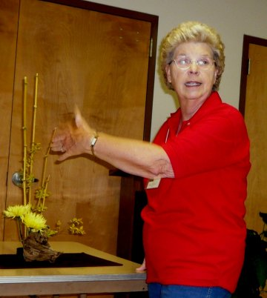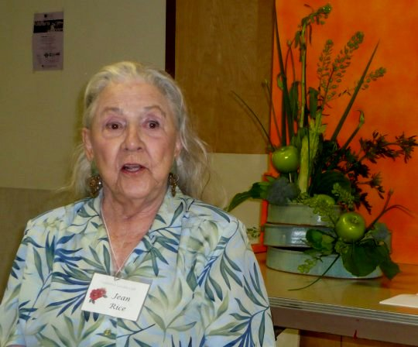
A REAL TREAT!
Those of you who missed the May meeting missed a real treat as not only did we have a great class on design presented by Barbara Schuette, a member of our club and a flower show judge, we also were privileged to have a presentation on “necessities in a designers tool box” made by one of our members, Jean Rice, flower show judge emeritus. Jean moves to warmer weather in the winter and is home for the summer. It was such a treat so see her and learn from her at the May meeting. Thank you Jean and Barbara!

TBA: Central District Bus Tour
Oct. 9: Central District Fall Meeting, Booneville
TBA: Central District Bus Tour
Oct.13, 1 pm: “Tread Lightly on the Earth”
Oct. 14-16: Landscape Design School IV, St Louis
Nov. 10, 1 pm: “Beyond the Bird Feeder”
Nov. 13, 14: FGCM Fall Board Meeting-TBA
Dec. 8, noon: Holiday Tea

Calendar of Events:
June 1-7: National Garden Week
June 7: CGC Flower Show-Columbia Public Library
June 9, 8:30 a.m.: Garden Tour: “Beyond Our Garden Gates”
August 7-17: Missouri State Fair (August 13th –Federation Day)
August 22-24: Flower Show School II
Sept. 15, noon: Annual Covered Dish Luncheon
“Natural Wonder beyond the Gate”

COLUMBIA GARDEN CLUB MINUTES MAY 12, 2008
The meeting was called to order by President Linda Lowenberg at 2:45 p.m. following the program which was presented by Barb Schuette, an experienced Flower Show Judge. She explained how each flower show entry is rated. Members had the opportunity to judge four entries. Carolyn Doyle, Columbia Garden Club Flower Show Co- Chair instructed member’s on the proper way to groom plants for horticulture entry. The schedule for the Flower Show was given to each member. Jean Rice informed us on what materials to keep handy when arranging flowers. Twenty-four members attended the meeting. The minutes of the April meeting were approved as printed in the CGC newsletter COLUMBIA UNDERGROUND.
Treasurer Karen Blackmore corrected the April Treasurer’s Report. The May Treasurer’s report shows a checking account of $3128.56 and a CD balance of $2888.28 for Total Assets of $6016.84. The net profit from the bake sale was $249.33. The net profit for the plant sale was $1,460.82. The report was filed for audit.
COMMITTEE REPORTS: 4-H Habitat Landscape – Co-Chair Marie Pasley reported that this is a year-long project. A family of four live in this home and the young people consult with them before doing any work. They have done painting and have built bunk beds. It has been difficult for them to do much work outside due to the rainy weather. They have planted four shrubs and two trees and a few annuals.
Wyatt House and Columbia Public Library Arrangements – Chair Lynn Birkby thanked Marie Pasley for taking an arrangement to Wyatt House and Mary Jane Wheeling for taking an arrangement to the library. The library will display a Memorial Day arrangement from Margaret Sullivan and a Father’s Day arrangement from Marie Pasley. Leona Litteral will provide an arrangement for Wyatt Guest House in May and Karen Blackmore will provide one in June.
Yard of the Month – Co-Chair Mary Jane Wheeling asked members to recommend yards that would be suitable for this recognition. She said the signs need some work.
Garden Tours – Chair Betty Gladney announced a change in the meeting place for car pooling. We will meet on the north side (the I70 side) at Parkade Shopping Center at 8:30 a.m.
Ways and Means – Co-Chair Mary Jane Wheeling thanked Marie Pasley for helping her set up for the Mother’s Day Basket Sale. Carolyn Swope, Cindy Deegan, Carol Notbahm and Connie Blackmore were thanked for helping with the sale. Mary Jane said that probably a net profit of approximately $100 will be realized.
NEW BUSINESS: Marie Pasley reminded us that the Judges Council has given a grant of $90 each to two clubs in Central District for a person in each of those clubs to attend the Flower Show School. The agreement was that the club receiving the grant would match with $90. CGC is one of the clubs that received a grant. Marie moved that the Columbia Garden Club pay $90 for a person from our club to attend Flower Show School. The motion was seconded by Carolyn Doyle. The motion was voted on and passed.
Art Schneider reminded us that our name is still on the Adopt a Spot on Forum Blvd. even though we are no longer caring for it. Mary Jane said she has asked that our name be removed but nothing has been done. Art said he would try to remove the name.
ANNOUNCEMENTS: Missouri Botanical Garden Tour is June 8. You can see the ten gardens on the tour by bus. The charge is $75.
The meeting was adjourned at 3:15p.m. Virginia Itschner, Secretary

Add space is available! Please let me know if you hear of anyone interested in placing an add in our newsletter.
This is the last newsletter until the September issue! It’s summer vacation! See you at the Flower Show and on the Garden Tour! Let’s all make extra effort to attend and make these the most successful events ever! Have a great summer!

