
NEWS OF THE COLUMBIA GARDEN CLUB

“SOW HOE AND GROW”
President: Mary Jane Wheeling 573 874 0006 Dec 1, 2008
Newsletter Editor: Karen Blackmore 573 442 1873 karen@kewpie.net

Just a note to thank you all for your support, guidance and friendship during my term as president of the Columbia Garden Club. It has been an honor and a pleasure to be a part of such a wonderful group of men and women. Thank you, Mary Jane Wheeling

Dec. 10, Noon- Bring finger food and we will see demos as we
“Sow the Seeds of Crafting”
Jan. 7, 2008 1:00- Regular meeting -program to be announced
Meeting location, unless otherwise stated: Trinity Presbyterian Church, 1600 West Rollins Road, Columbia, Mo. 65203

At the November Meeting:
DORIE DRAPER SHARED HER BEAUTIFUL BOTANICAL DRAWINGS
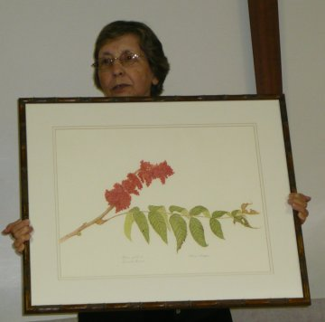
I know you were as amazed as I was to see Dorie’s beautiful drawings. I did not know what to expect as I had never seen her work. I have been wanting to buy pencils and an easel ever since but realize it takes a great amount of talent to accomplish what she accomplishes. What treasures she creates!

Columbia Garden Club Minutes November 12, 2007
The meeting was brought to order by President Mary Jane Wheeling at 2:00. Mary Jane read the inspiration.
Marty Buell mentioned that bittersweet was brought by Art Schneider and Betty Gladney brought the hibiscus.
The October Garden Club minutes were corrected: Grace Edwards had been the president of our club twice and had also been a State President.
Treasurer’s Report: Alice Havard presented the treasurer’s report, total assets: $4,634.29
CORRESPONDENCE: *Mary Jane received another thank you note for the donation of our flowers each month from Ellis Fischel Hospital. *Superior Garden Center is offering a class on Nov. 17th, “Caring for Your House Plants” *The Wayland’s sent a thank you note for being selected a “Garden of the Month” house. *Mary Jane received a reminder about the Twin City Garden Club’s 50th Year Anniversary Tea – held tomorrow, Nov. 13. A few of our members are planning to attend. *Mary Jane received a letter from Mike Schmidt of the American Hosta Society regarding their convention which will be held in St. Louis June 11 – 14th, 2008. See Mary Jane for more information.
COMMITTEE REPORTS: Garden Therapy: Karen Blackmore reported that she gave the 15 minute video to approximately 20 Columbia Manor residents. Karen had made the video – a walking tour of her own garden – just after the Garden Club’s Tour last spring. Scholarship: Barb Devine reported that Katie Gessling was the recipient this year. Katie is attending MU and was highly spoken of by her teachers and counselors at Hickman H.S. Barb also reported that she invited the high school students at Rock Bridge and Hickman to participate in the State Garden Club Essay contest. Smokey the Bear/Woodsy Owl Poster Contest: Barb Devine reported that Rock Bridge Elementary School 2nd and 3rd graders entered this last year. This year Blue Ridge School 3rd graders will be participating. Historian: Judy Stephens has been taking care of the scrapbook. We will need to fill this position. Garden Tours: We need three more gardens to fulfill the five gardens required for this. Hospitality Committee: Connie Blackmore has volunteered to co-chair this committee with Barb Devine.
NEW BUSINESS: Junior Garden Club: The Russell Blvd. Elementary School Adventure Club has about 15 students interested in the club. Linda Lowenburg and Marie Pasley will be in charge of this, but need helpers. Please let them know if you’d like to join.
Flower Show School: Marie Pasley will have brochures. The first of four sessions will be April 11, 12 in St. Louis. The cost is approximately $100.00.
December Meeting: This will be our Holiday Tea at 12:00 noon. Bring your favorite finger foods to share and items for the Food Bank. We will also have opportunities to see a craft demo and work on projects if you would like.
Respectfully submitted, Barb Devine
COLUMBIA COLLEGE PRESENTED WITH THE BUSINESS CITATION AWARD
Employees of Columbia College grounds department were present to receive the CGC citation for the prettiest business grounds created and cared for completely by the business. Keep an eye out for the beauty next spring as the 6000 bulbs recently planted on Columbia College campus bloom!
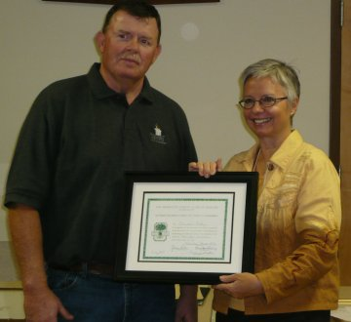 Julie Fisher makes a presentation to Columbia College Meet a new member- Sue Williams
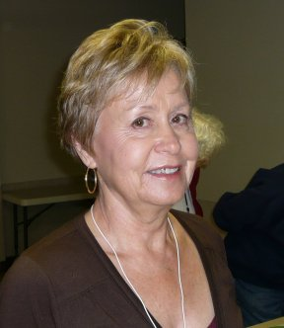
Sue Williams and her husband live near Sturgeon Mo. where they farm and sell real estate. She is a former Art teacher and a practicing artist. They have two grown children, Crystal and Hugh and an 8 year old grandson, Will. I know we’ll enjoy her talents and that you will help make her feel welcome in the years to come.
Have a Merry Merry Christmas! Make sure you update your calendar with all the dates for Columbia Garden Club meetings in 2008. During the rest of the winter, as you are browsing the internet, simply enter simple things like –free gardening articles or how to care for house plants or when and how to prune trees if you have plans to prune in February. This is a miraculous tool and has so much information available at your finger tips. If you do not have a computer, call me and I will print articles that you need. Thank you for a great year of friendship and I look forward to a warm and fuzzy 2008 with my gardening friends. Happy New Year! Karen Blackmore

K

New years


