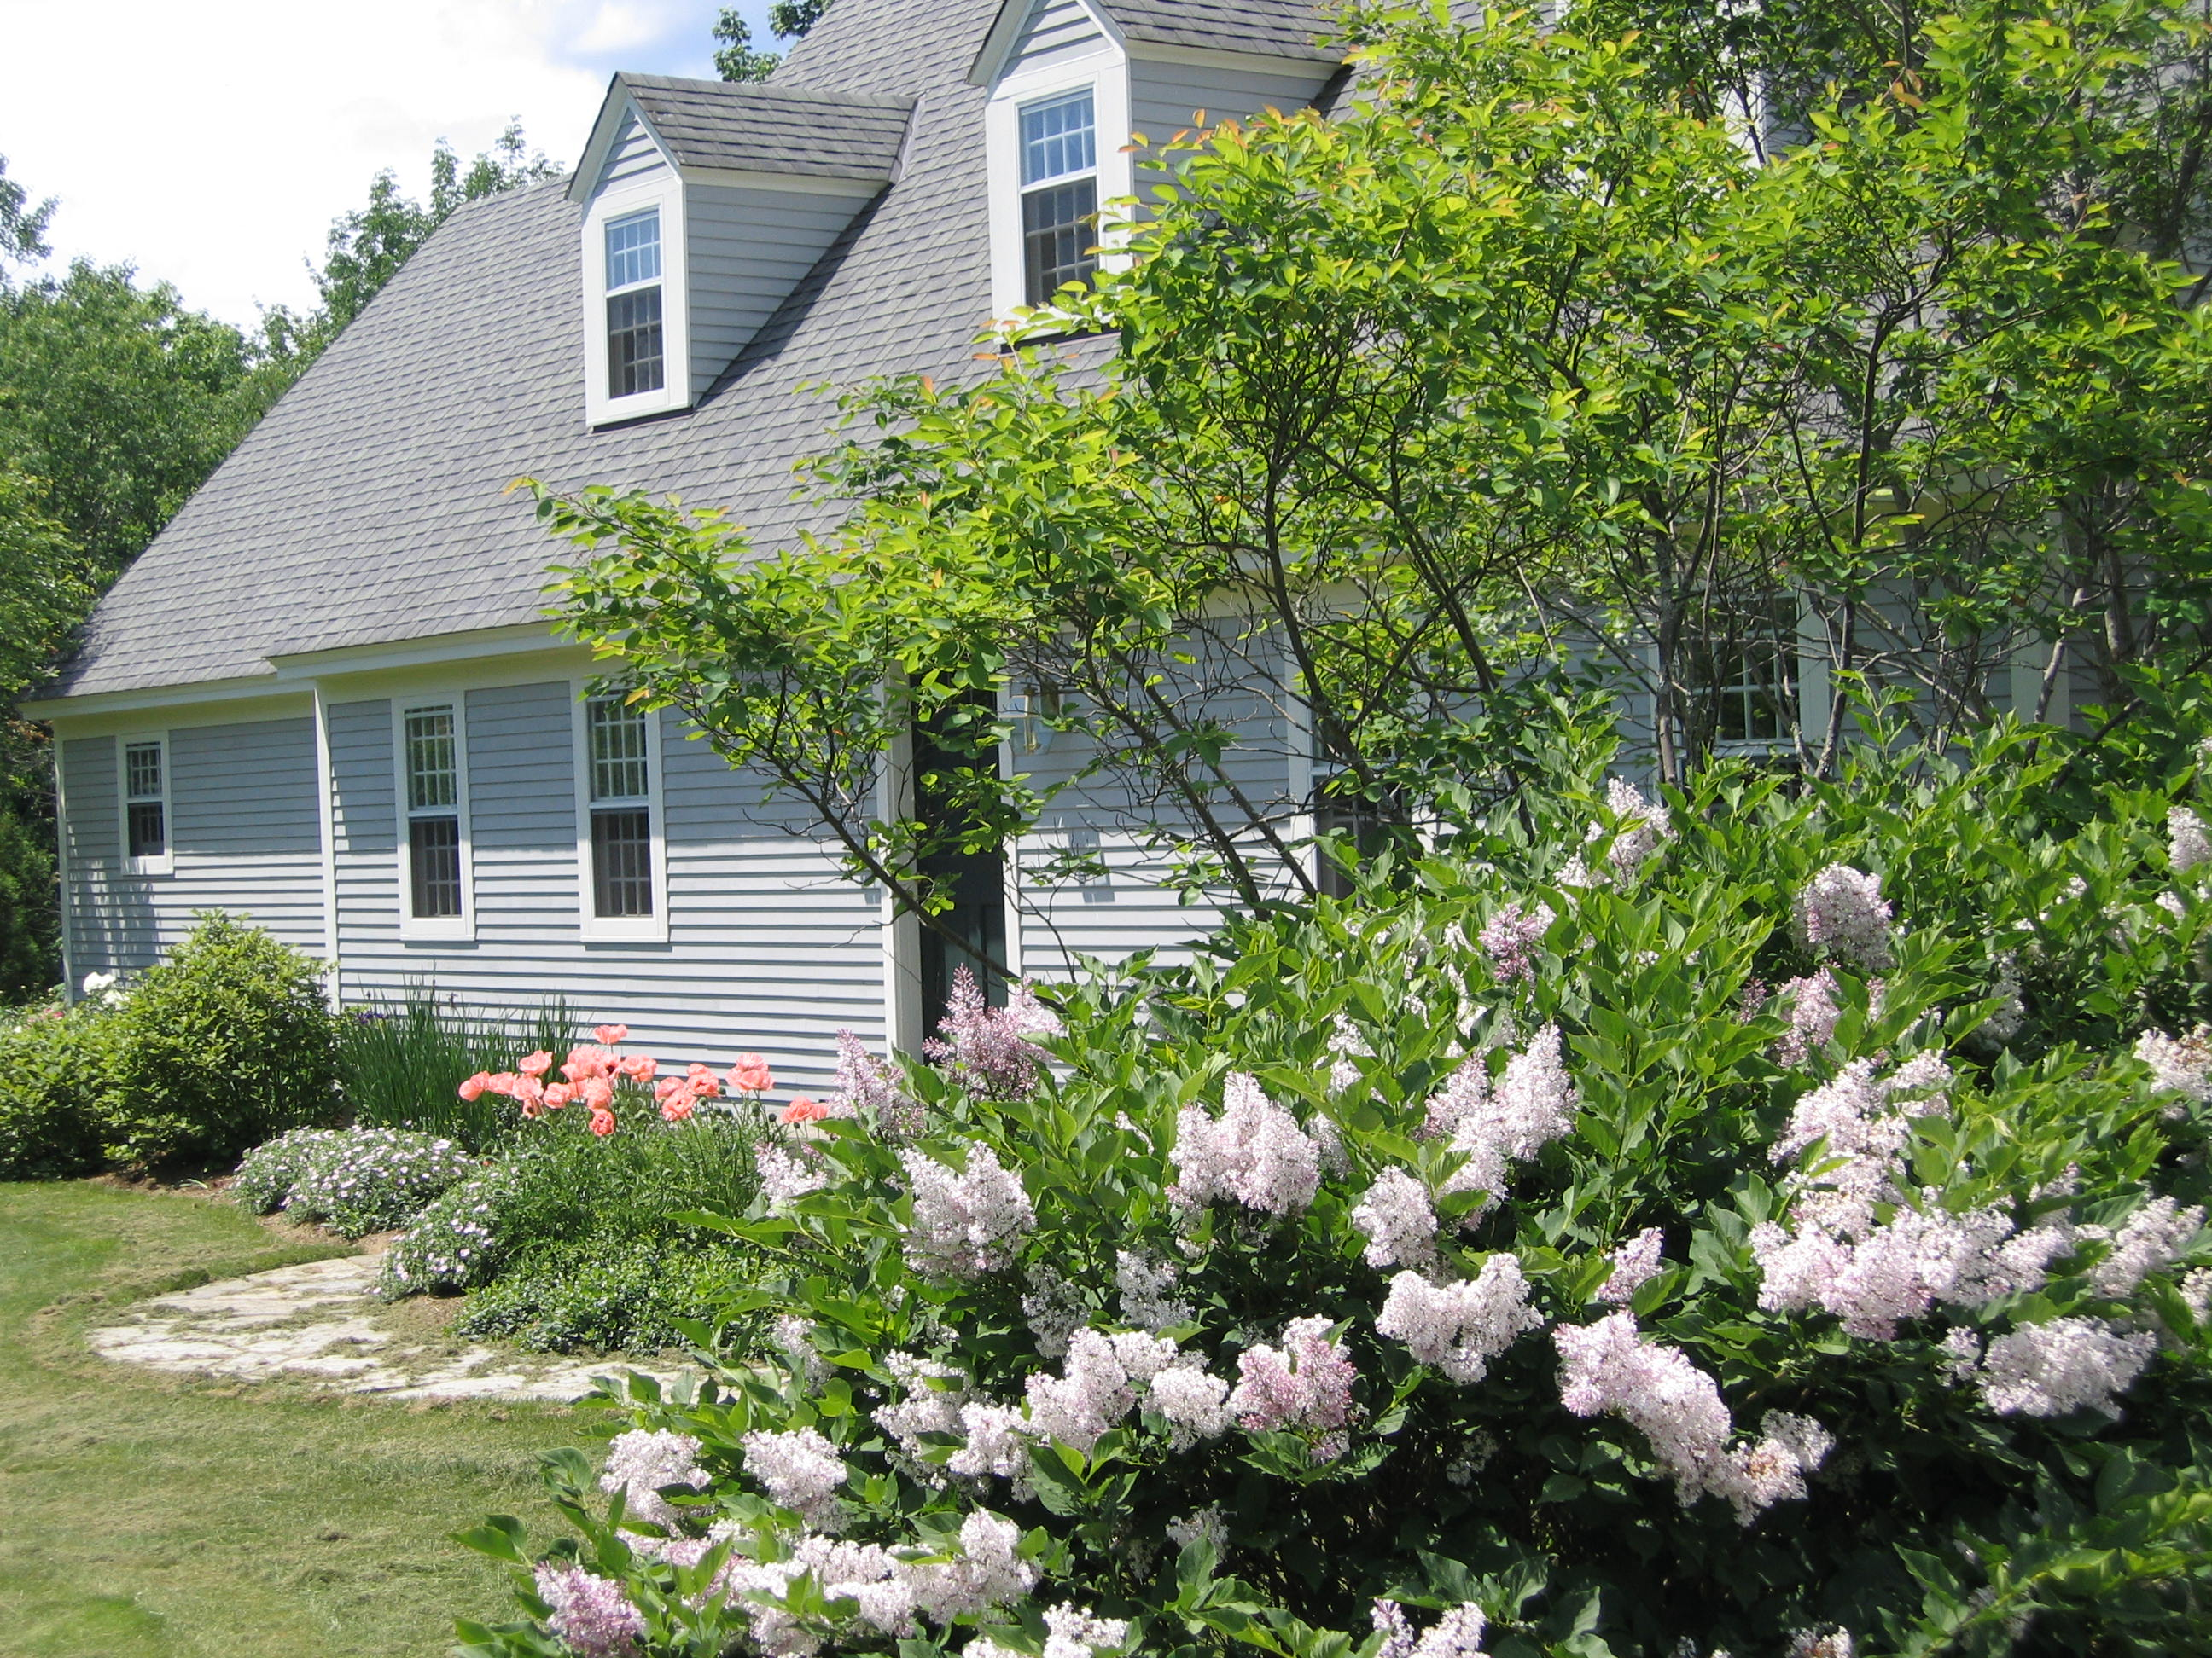
179 Upper Turnpike Rd.
Norwich, VT 05055

August 30, 2007

Dear Friends and Family:

This is a very late New Year’s greeting from Vermont. This year will mark the 15th year for the Modlins on Upper Turnpike Rd., a one lane dirt road about 4 miles from the local general store, Dan and Whit’s, the major landmark in Norwich by which everyone orients themselves and others. The year flew by without any life defining events although Andrew came close when he drove his Honda Element off the road (on the way back from Dan and Whit’s – he was hungry and didn’t want to cook for himself) over Thanksgiving break. The car was totaled, but fortunately, he survived with all but his ego intact.
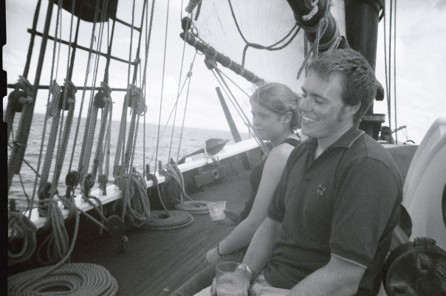
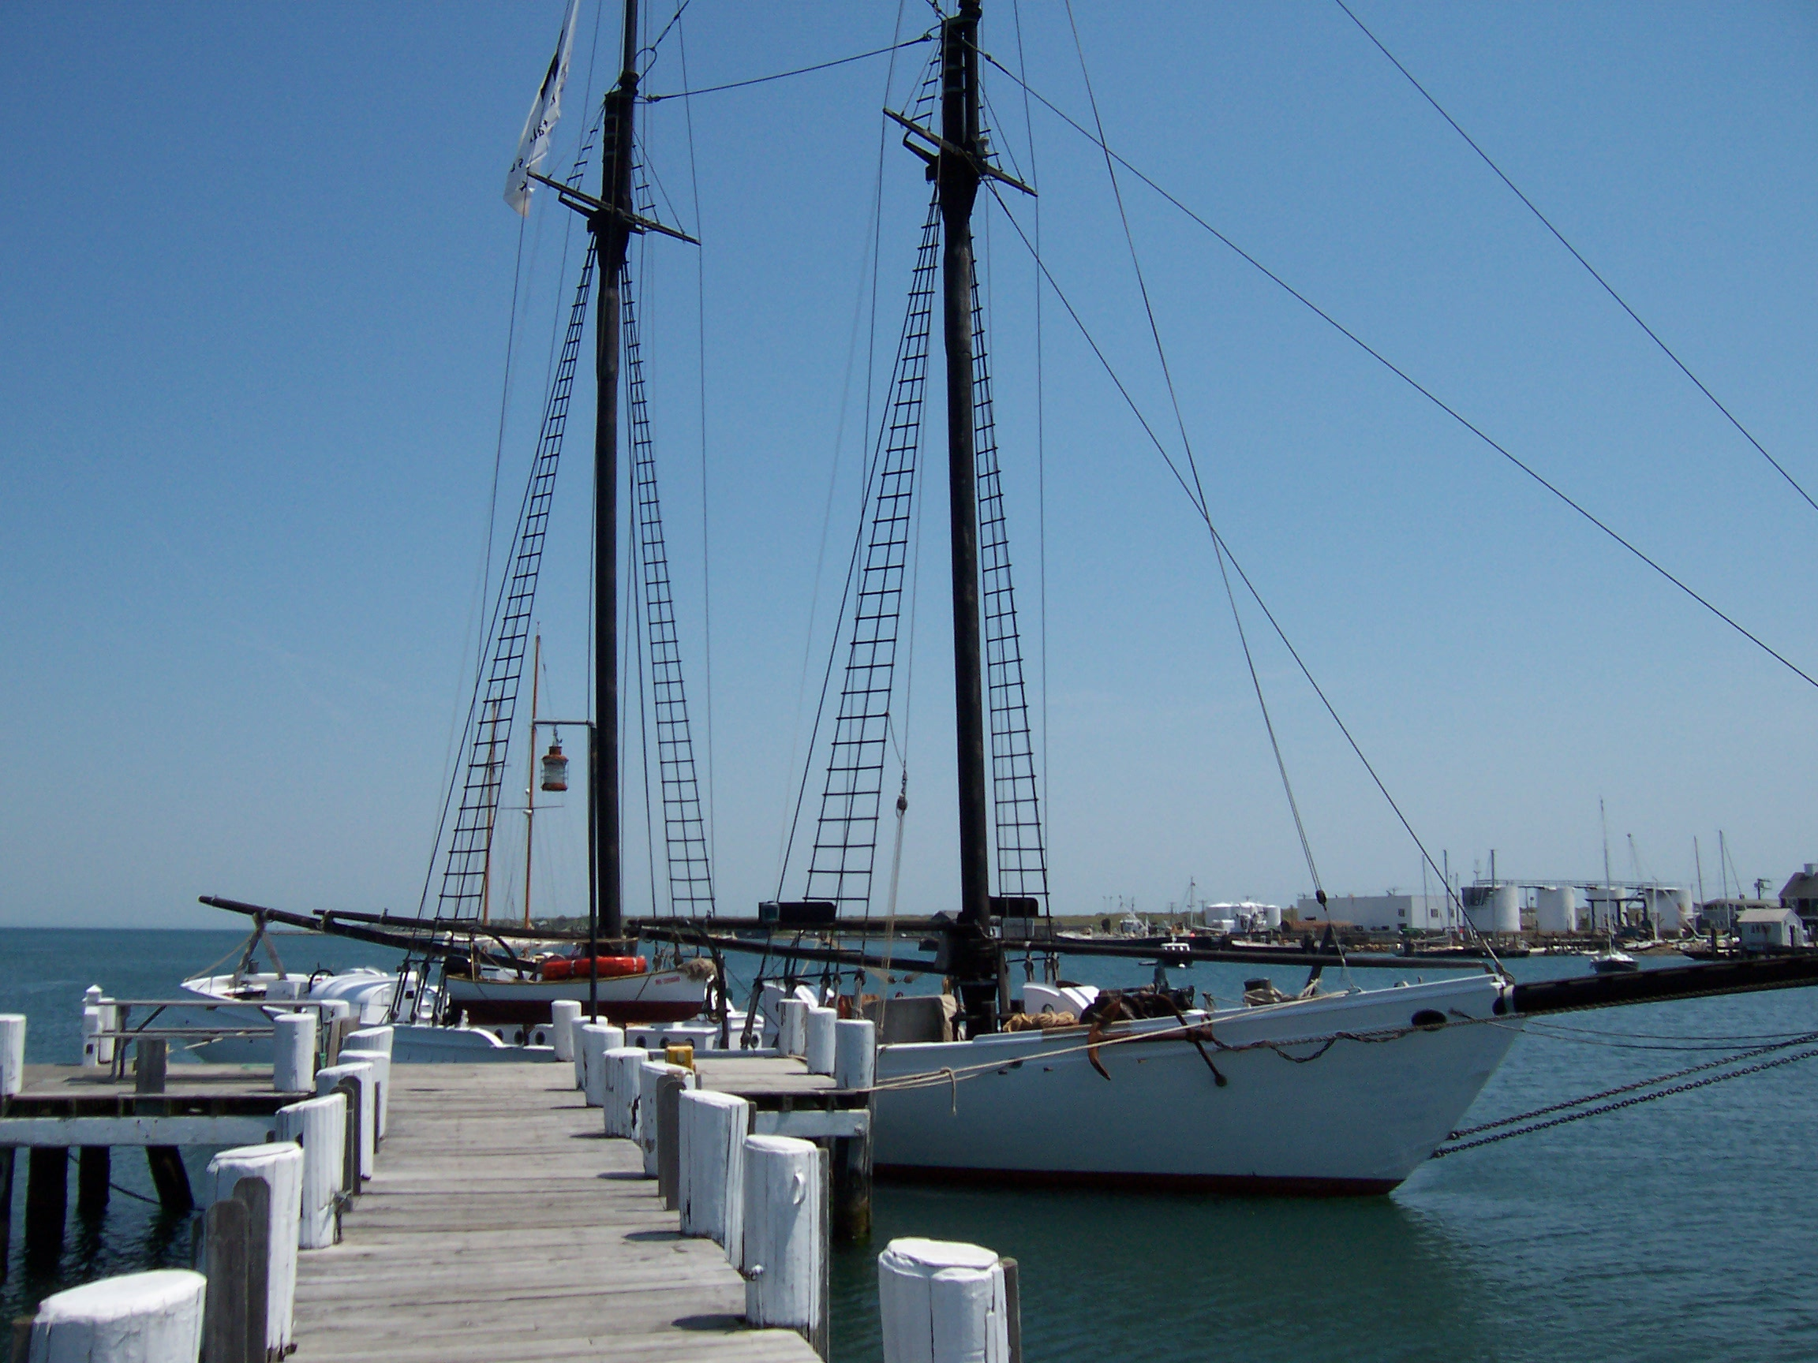
Andrew, now car-less, is a junior at the University of Vermont majoring in skiing and environmental studies. He shares an apartment with 3 others in the student slums near downtown Burlington, convenient to all the bars on Church St. Andrew is one of the standout skippers on a very successful UVM Sailing Team and is considering extending his senior year by a semester in order to sail the Caribbean with a buddy from Tabor Academy. He spent last summer crewing on a 92 foot charter topsail schooner out of Vineyard Haven and will likely rejoin the crew next summer.


Chelsea, mostly on her own initiative, climbed Mt. Kilimanjaro in March with a group of students from Canada and the U.S. After the descent, they spent a week helping to construct a village school house in Tanzania. It was a defining experience. She will graduate from Tabor Academy in May, 2008, spend the summer at Crystal Lake, and then enroll in Carleton College next Fall.

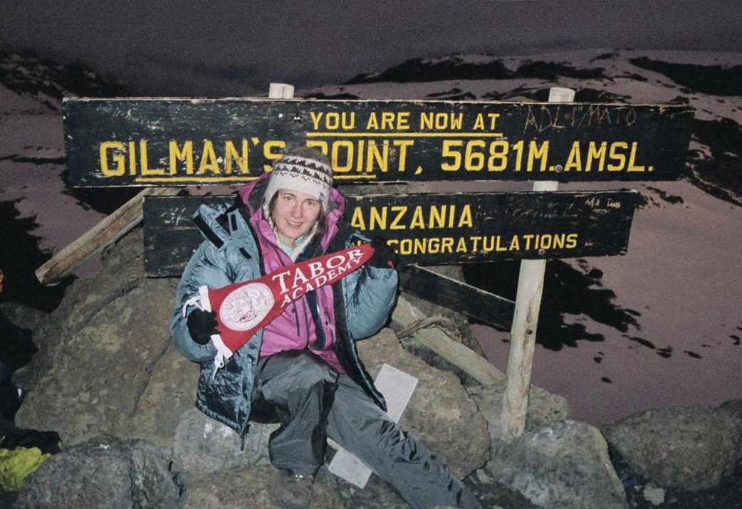
Sharyn continues in her second career as a child abuse investigator for the Vermont Department of Health and Human Services, based out of White River Junction. She brings her work and her sense of justice and compassion home every night.
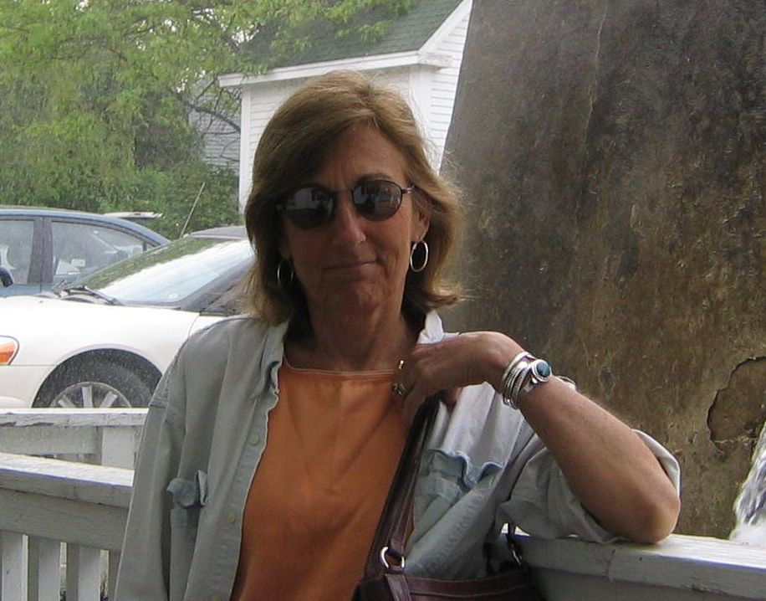
John is still hanging on to the reins of a rapidly growing Department of Pediatrics at Dartmouth while making an effort to contribute to vaccine public policy via advisory committee work with the CDC and FDA.

We split the summer at Crystal Lake this year, Sharyn taking most of July and John most of August, in order to keep some semblance of parental presence near Chelsea who was employed nearby. The photo below is the crew of the E scow Venture taken some time this August on Crystal Lake after setting a modern day record for the oldest crew on board – a total of 275 years. The skipper and crew characteristically took the record in stride and later celebrated at the early bird special at Dinghy’s Bar and Restaurant.
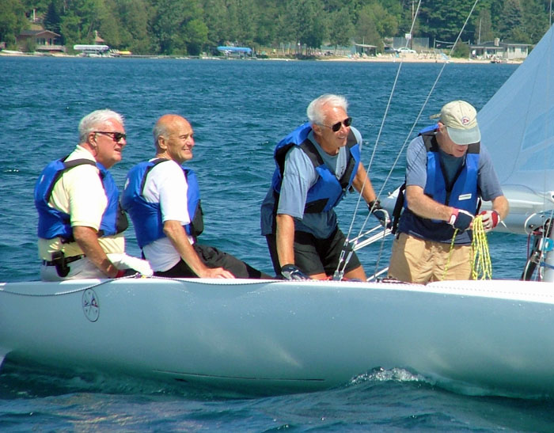
This summer we hope to move into a new summer home on Lake Michigan, a project that has taken at least 5 years from concept to reality. If you happen to be anywhere within striking distance of northwest lower Michigan (nearest airport is Traverse City) this summer, please let us know. There will be a combination house warming and 25th anniversary party on the dunes sometime in mid August.

Warmest regards,
John, Sharyn, Andrew and Chelsea



